1. **Installing Apache Web Server**
2. Before installing Apache Web Server, login first to the server.

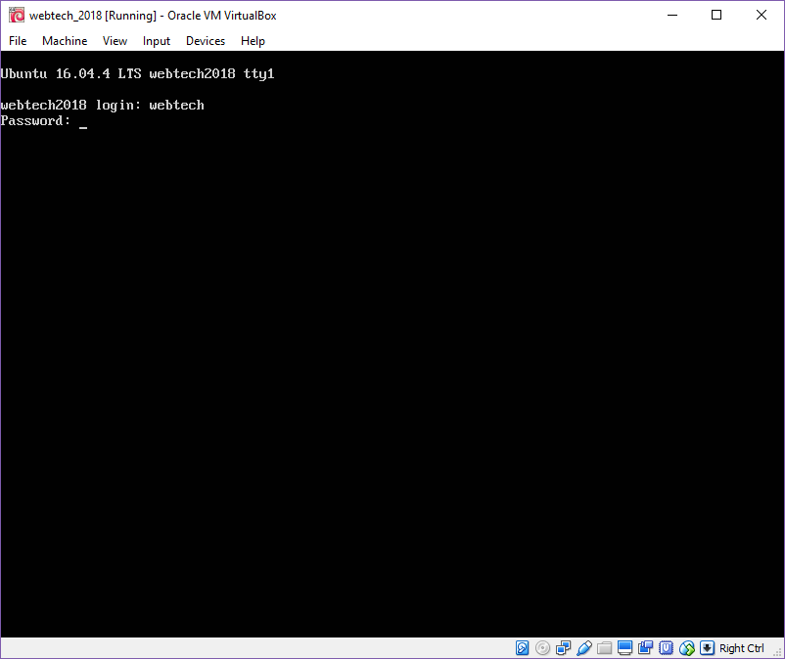

Figure 1: Logging to the server.

1. After logging in, update it using the command:

*sudo apt-get update*

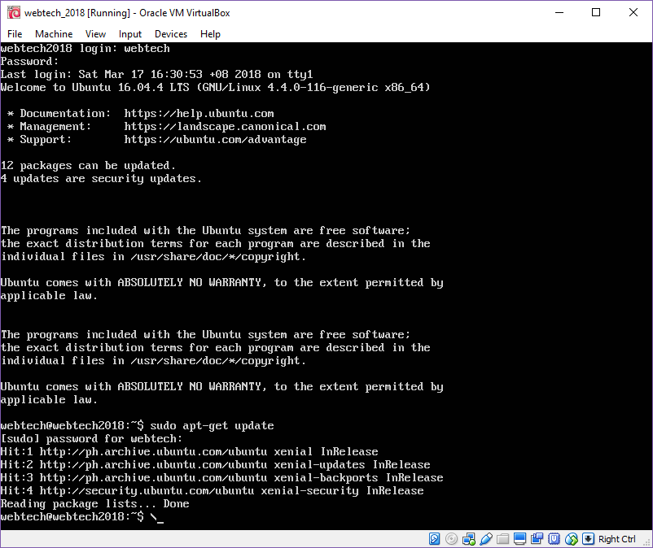

Figure 2: Updating the server.

1. To install Apache Web server just type:

*sudo apt-get install apache2 apache2-utils*

This command also installs its documentation and the collection of utilities in Apache.

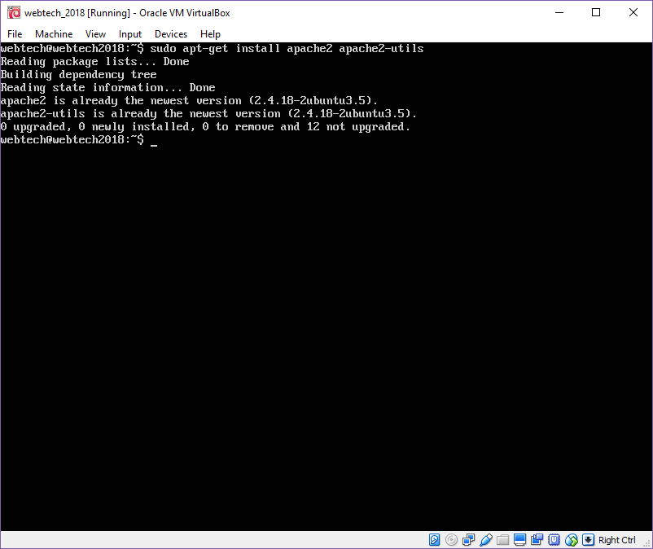

Figure 3: Installing Apache Web Server utilities.

1. To enable Apache2, just type:

*sudo systemctl enable apache2*

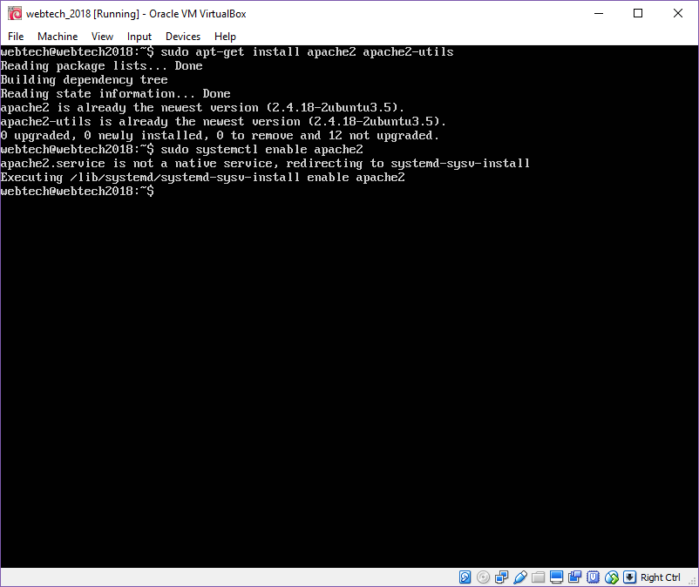

Figure 4: Enabling the apache2.

To start Apache2:

*sudo systemctl start apache2*

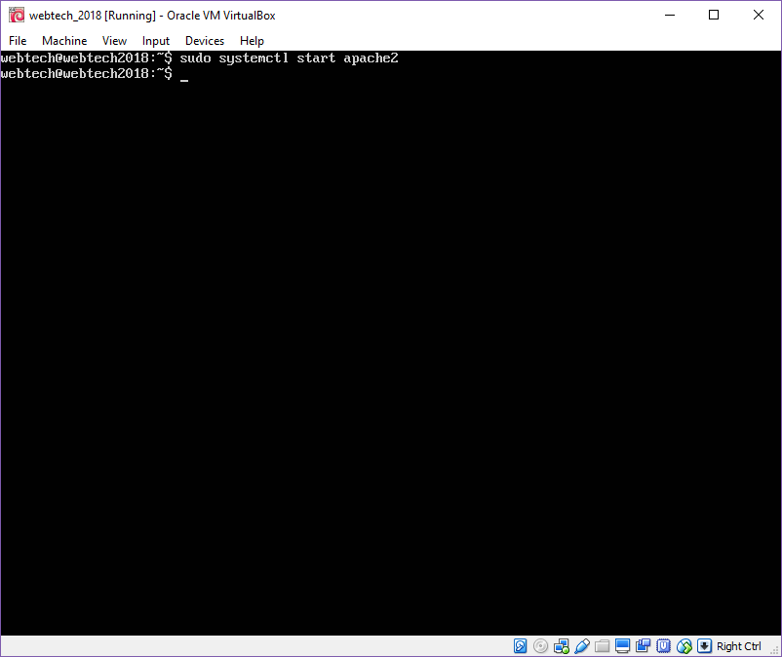

Figure 5: Starting the apache2.

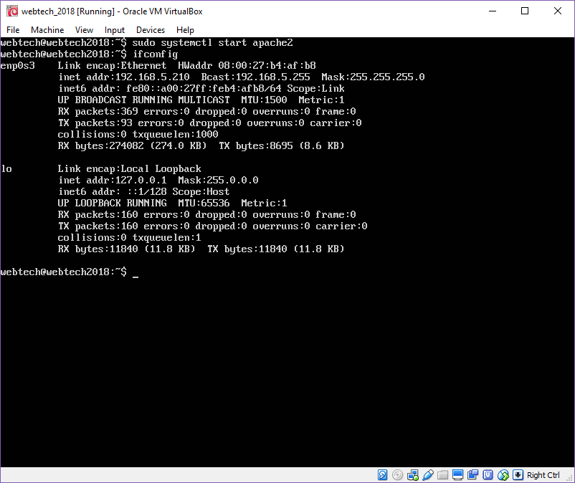

Figure 6: Displaying the current network configuration information.

1. Now, check if the server is running or not, open the webserver and type **http://”IP address of the VM”**.

If the web server is running, the default page of Apache2 must display in the browser

* All web files will be saved in the root directory /var/www/html/.

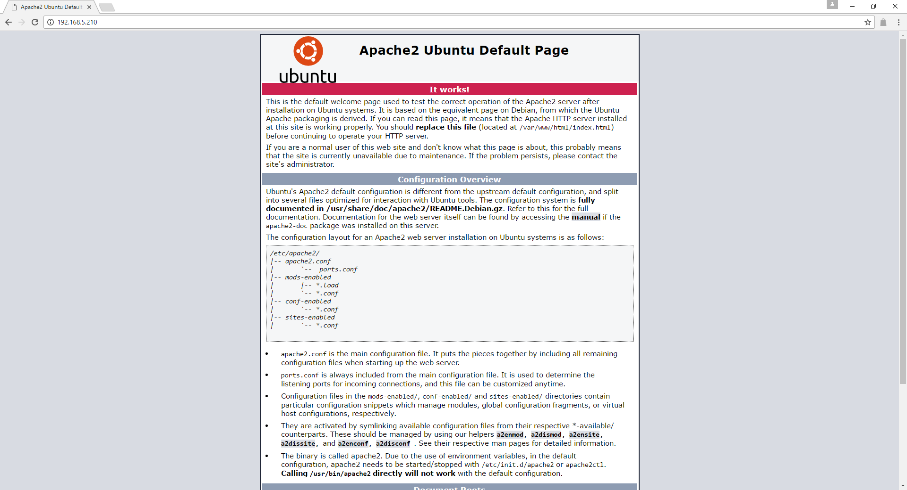

Figure 7: Checking if the server is running or not.

1. **Installing MySQL Database Server**
2. To install MySQL Database Server, type:

*sudo apt-get install msql-client mysql-server*

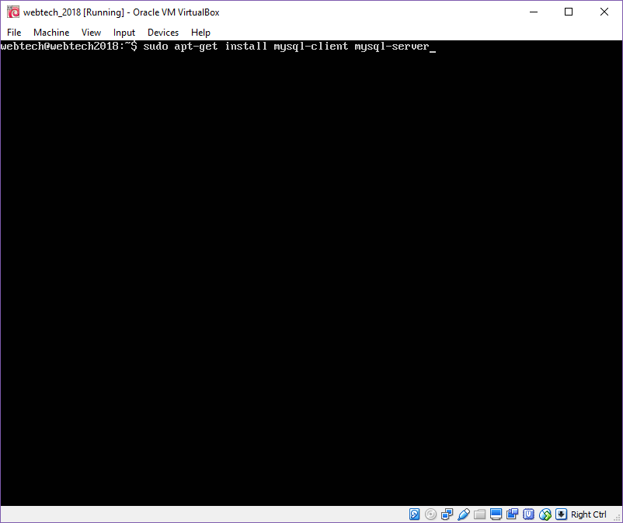

*Figure 8: Installing MySQL.*

During the installation of the MySQL package configuration, it will prompt a message that ask to set a root password of the user for MySQL. Type a secure password, then click OK to proceed.

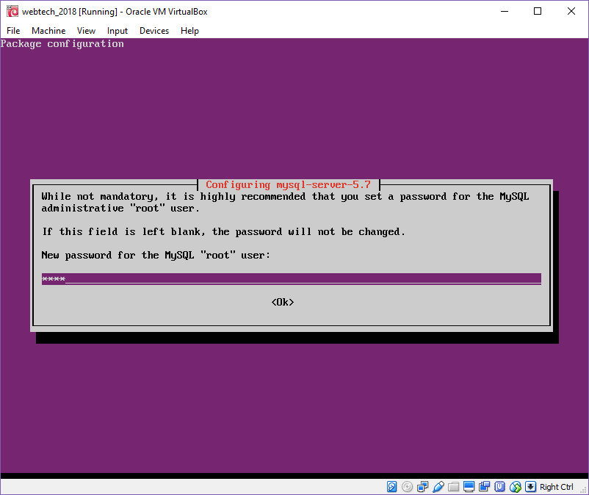

Figure 9: Setting up a root password.

It will prompt another message to repeat the root password of the user for MySQL.

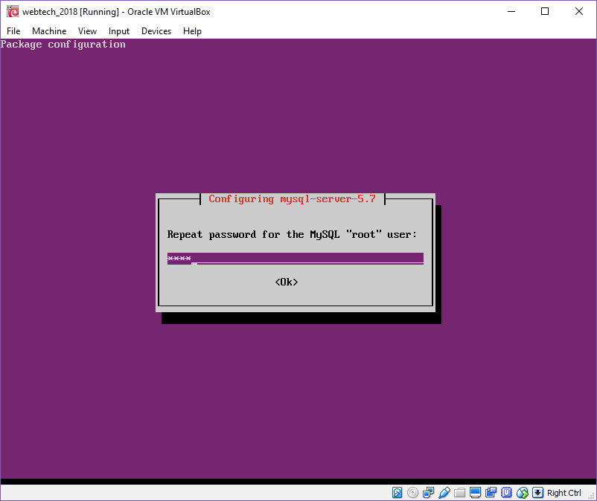

Figure 10: Confirming the root password.

1. Since the Database Server in not yet secure, in order for the security to be strong type the following command:

*sudo mysql_secure_installation*

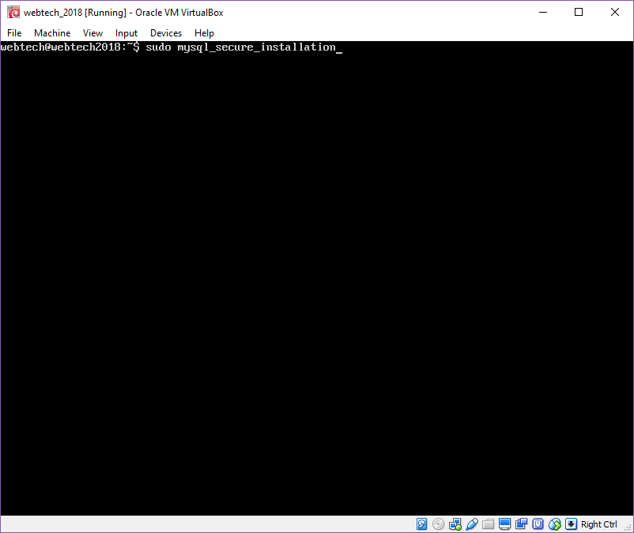

Figure 11: Securing the Database.

It will ask the password for user root, so type the root password you assigned.

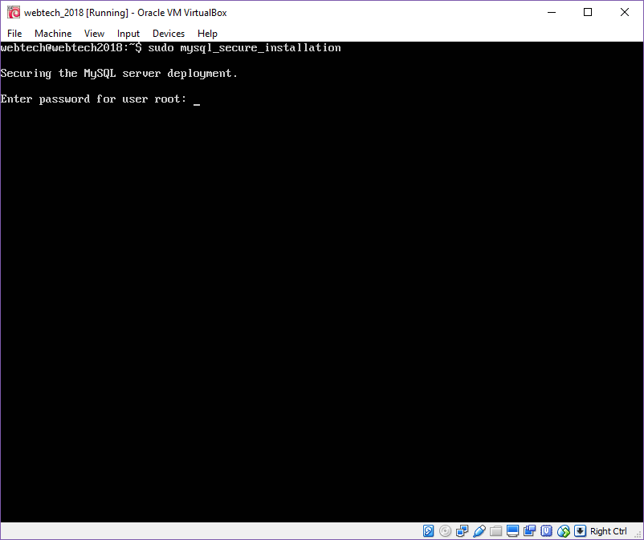

Figure 12: Entering the password for user root.

1. **Installing PHP and Modules**
2. In order for the web and database server to work, type:

*sudo apt-get install php7.0 php7.0-mysql libapache2-mod-php7.0 php7.0-cli php7.0-cgi php7.0-gd*

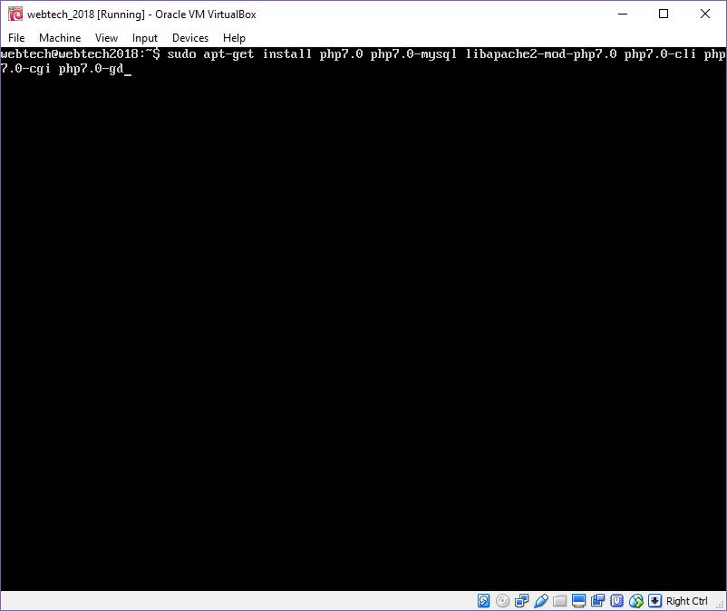

Figure 13: Installing PHP and Modules.

1. To test if php is working with the web server, create a info.php file in the directory /var/www/html

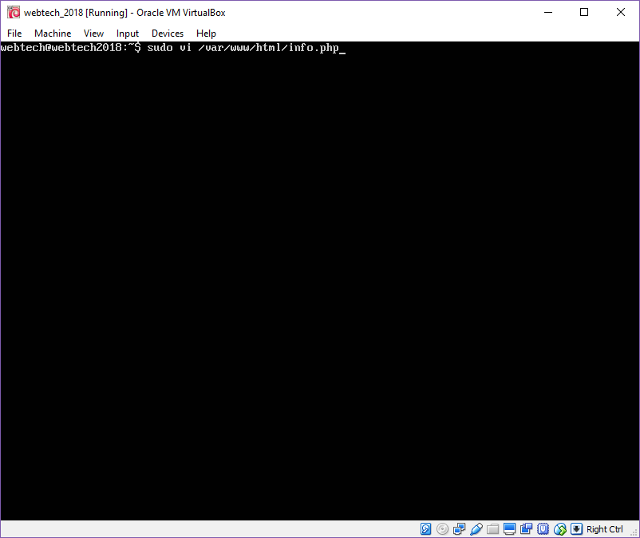

Figure 14: Creating the info.php file.

1. Copy the following code, then save and exit.

*<?php*

*phpinfo();*

*?>*

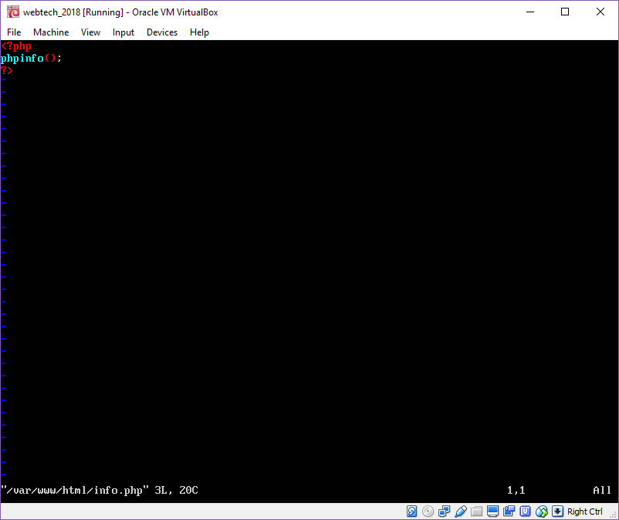

Figure 15: Creating the content of the info.php.

1. To check the server is running or not, open the webserver and type **http://”IP address of the VM/info.php”**.

If the web server is running, it will display the php info page.

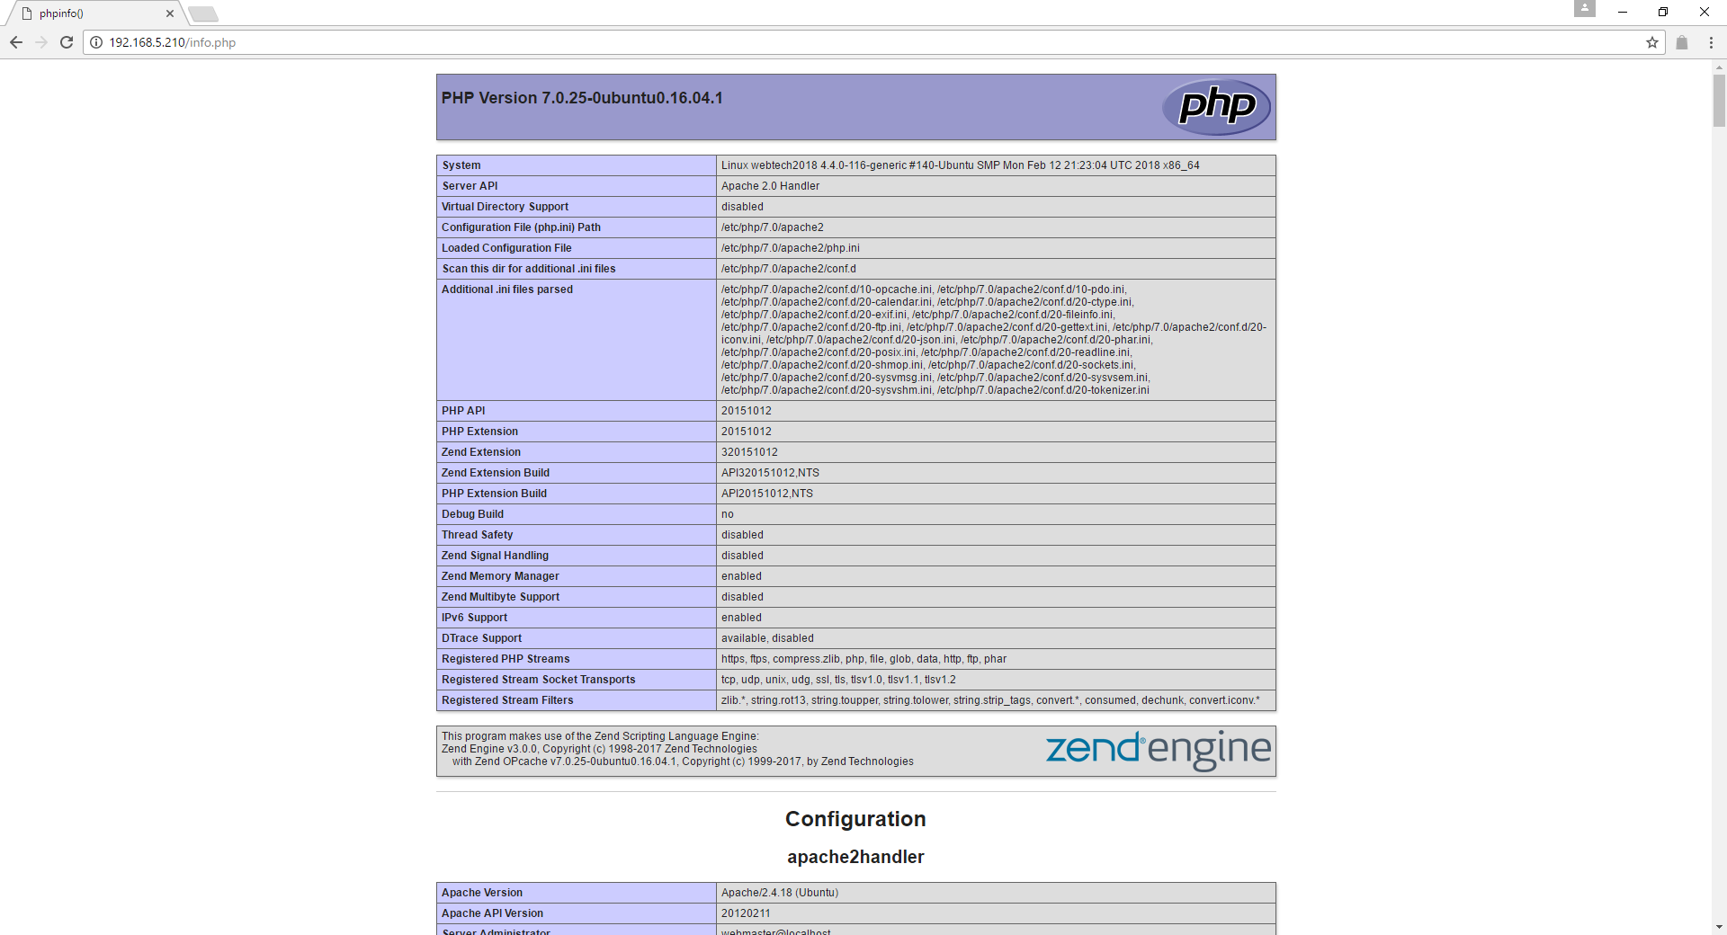

Figure 16: Checking if the server is running or not.

1. **Installing Wordpress CMS**
2. To download the latest WordPress package, type :

*wget -c http://wordpress.org/latest.tar.gz*

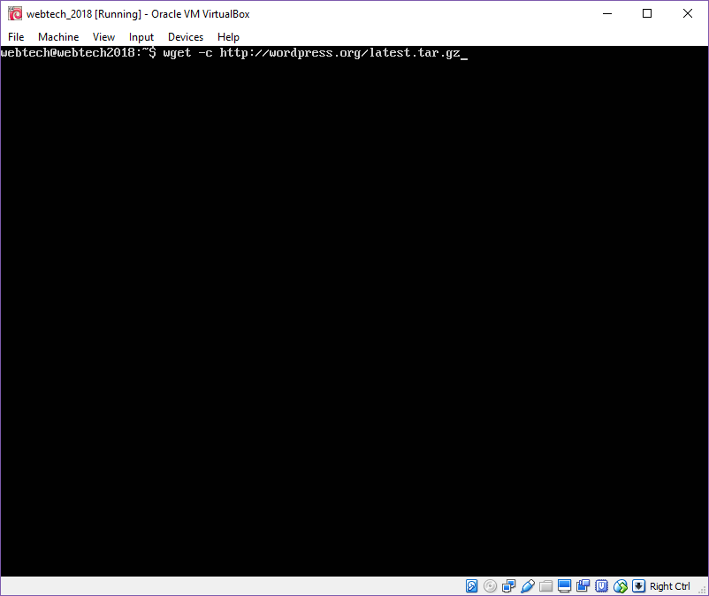

Figure 17: Getting the latest version of WordPress.

1. To extract the WordPress package use the command:

*tar -xzvf latest.tar.gz*

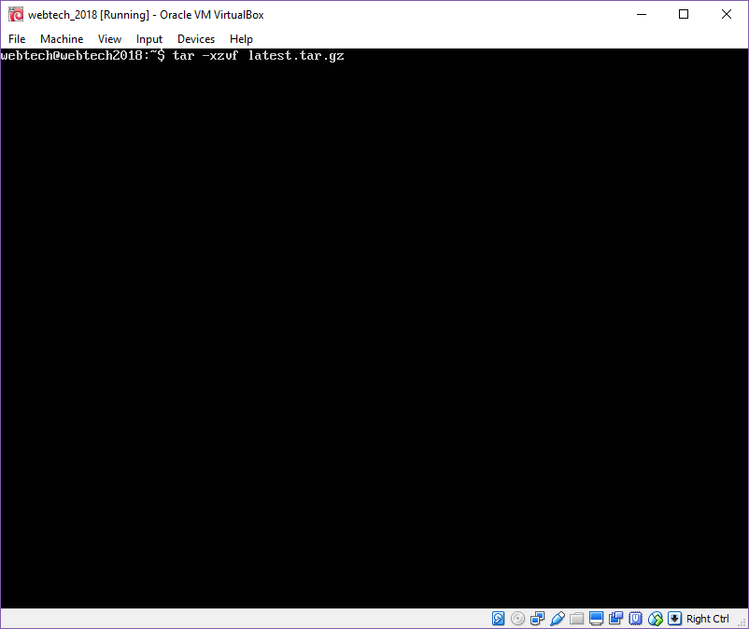

Figure 18: Extracting the WordPress package.

1. Move the extracted folder of WordPress to the default root directory of Apache2 which is /var/www/html/, type:

*sudo rsync -av wordpress/* /var/www/html/*

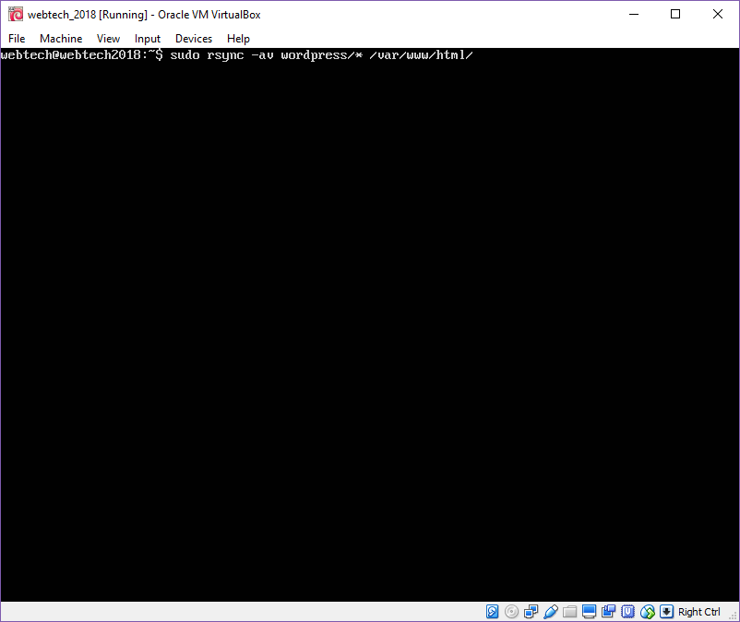

Figure 19: Moving the extracted folder of WordPress.

1. Next is to set ownership on the website directory, do this by typing:

*sudo chown -R www-data:www-data /var/www/html/*

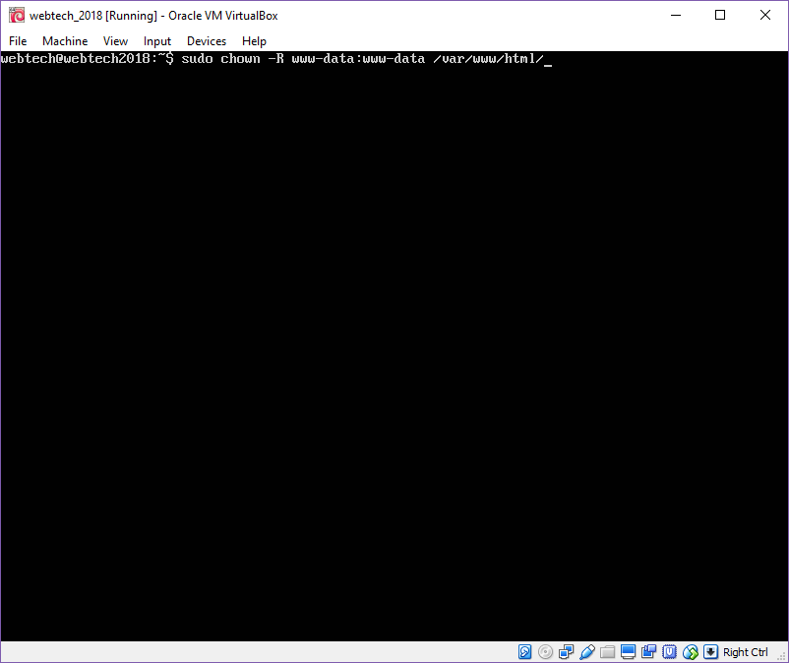

Figure 20: Setting ownership to the directory.

1. Then set permission to the directory, do this by typing:

sudo chmod -R 755 /var/www/html/

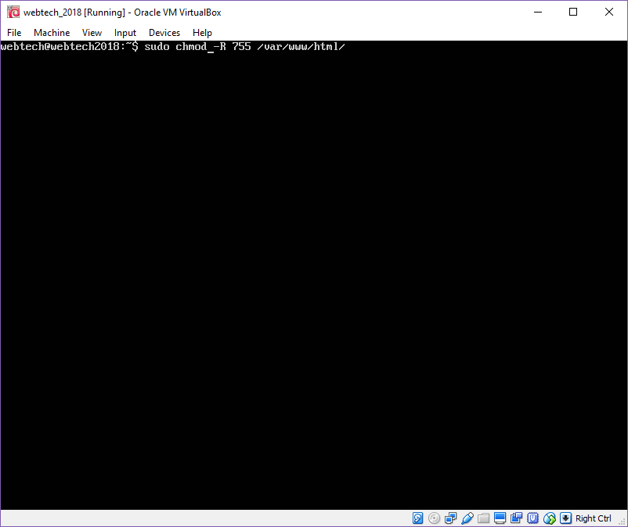

Figure 21: Setting the permission to the directory.

1. **Creating a WordPress Database**
   * 1. Type the following command and provide the user password for the database.

*mysql -u root -p*

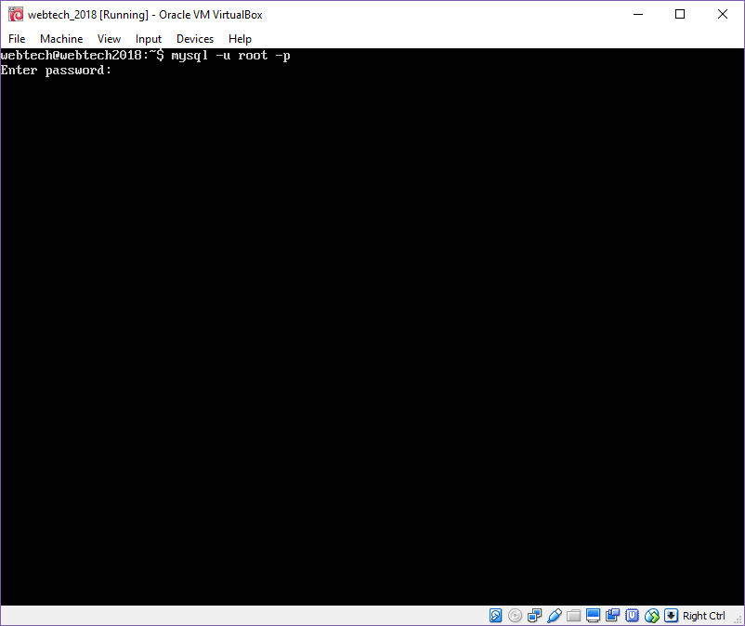

Figure 22: Resetting MySQL root password.

* + 1. Type the following in the msql shell, indicate a valid database_name; database_user and a strong databaseuser_password.

*CREATE DATABASE ‘databae_name’;*

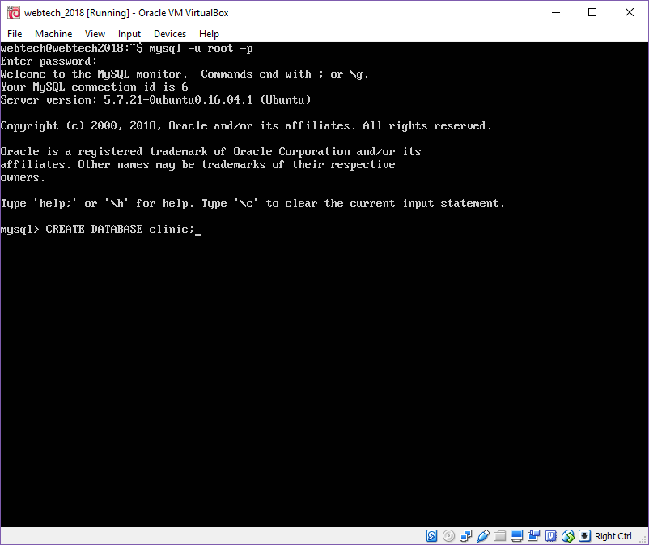

Figure 23: Creating the database.

*GRANT ALL PRIVILEGES ON ‘database_name.*’ TO ‘username’@’localhost’ IDENTIFIED BY ‘password’;*

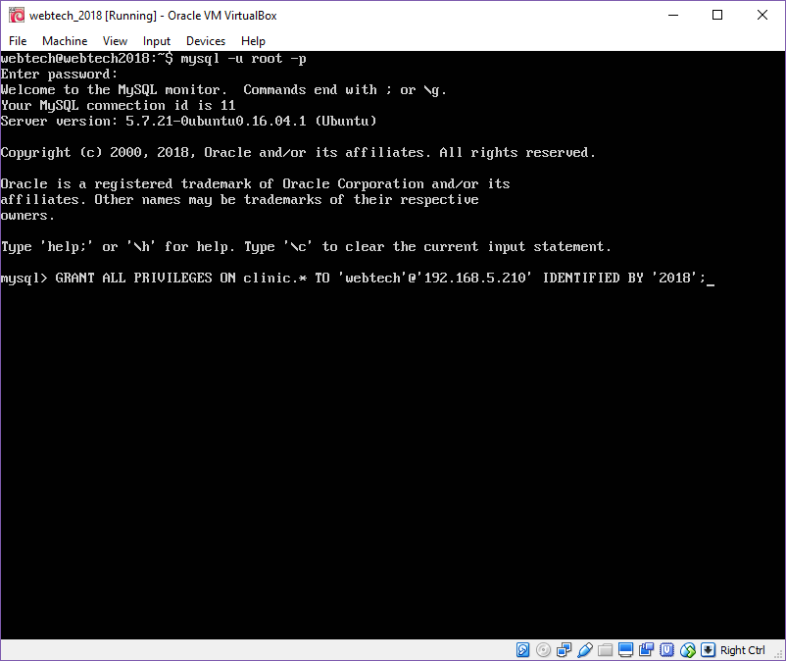

Figure 24: Granting the privileges.

*FLUSH PRIVILEGES;*

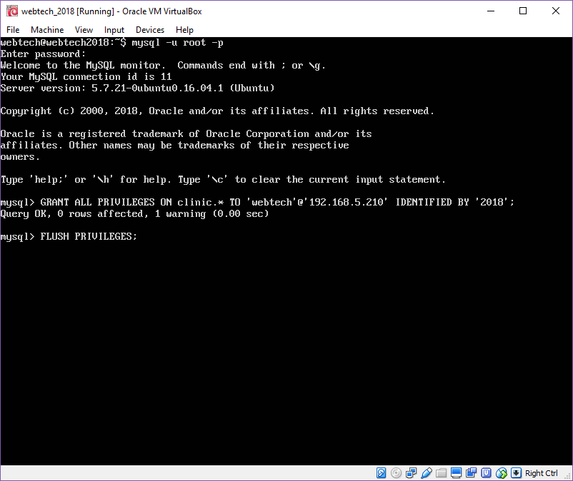

Figure 25: Flushing privileges.

*EXIT;*

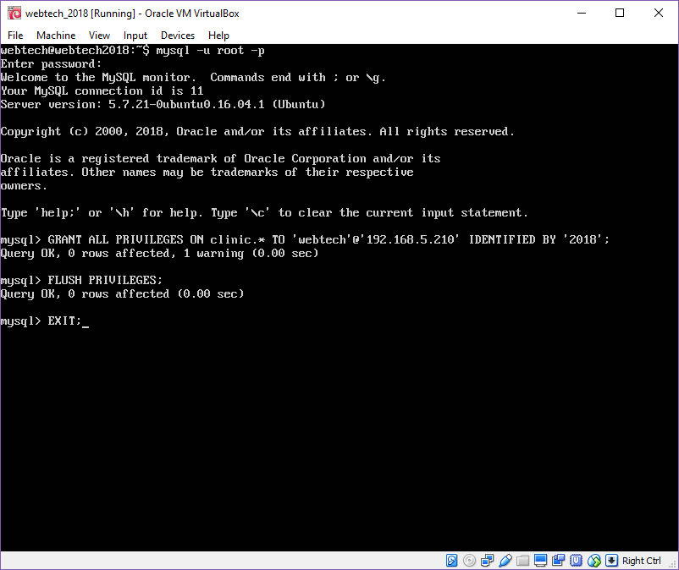

Figure 26: Exiting mysql.

* + 1. Go to the root directory and rename the existing wp-config-sample.php to wp-config.php by using the command:

*sudo mv wp-config-sample.php wp-config.php*

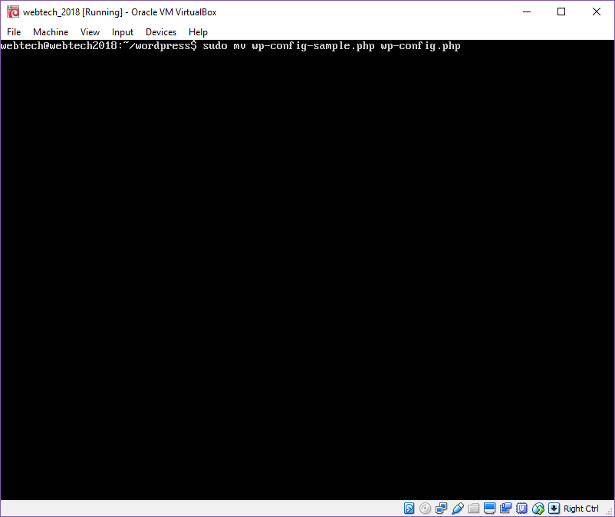

Figure 27: Renaming the existing wp-config-sample.php

* + 1. Next is to update the database information of the user under the MySQL setting section. Use the command to edit the user information.

*vi wp-config.php*

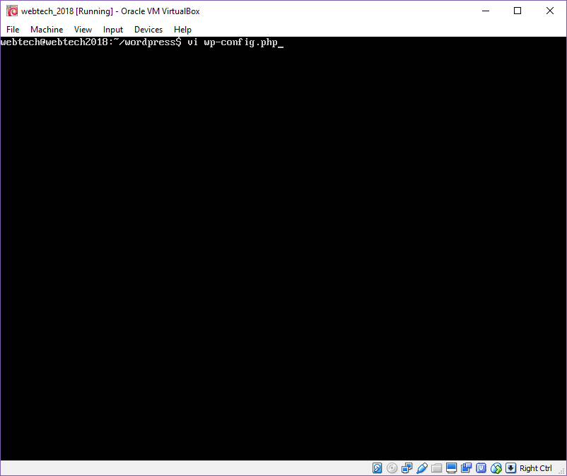

Figure 28: Opening the wp-config.php.

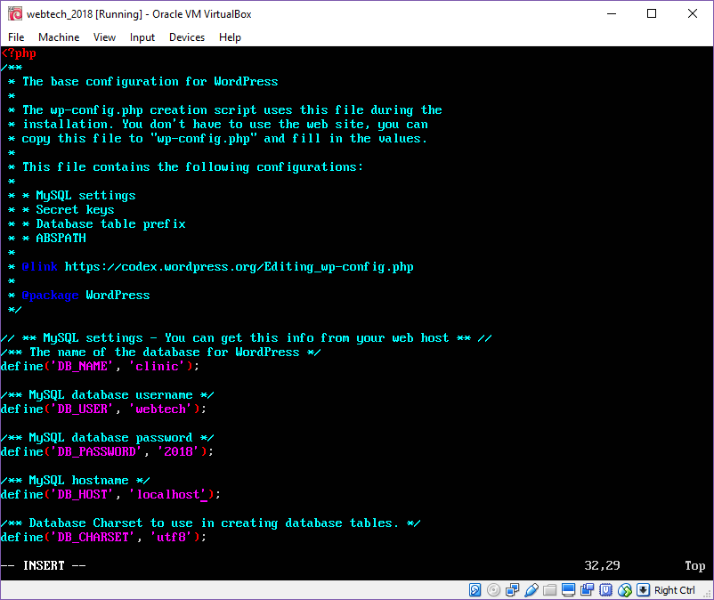

Figure 29: Editing the database information.

* + 1. After editing the database information of the user, next is to restart Apache2 and MySQL using the following command:

*sudo systemctl restart apache2.service*

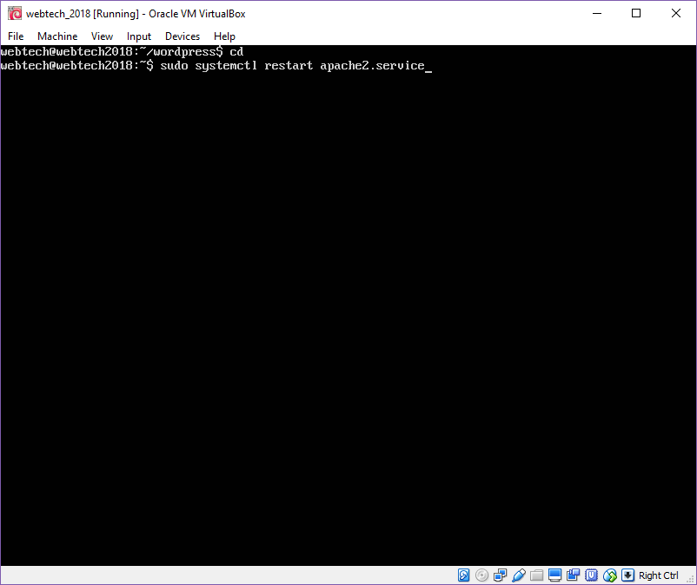

Figure 30: Restarting Apache2.

*sudo systemctl restart mysql.service*

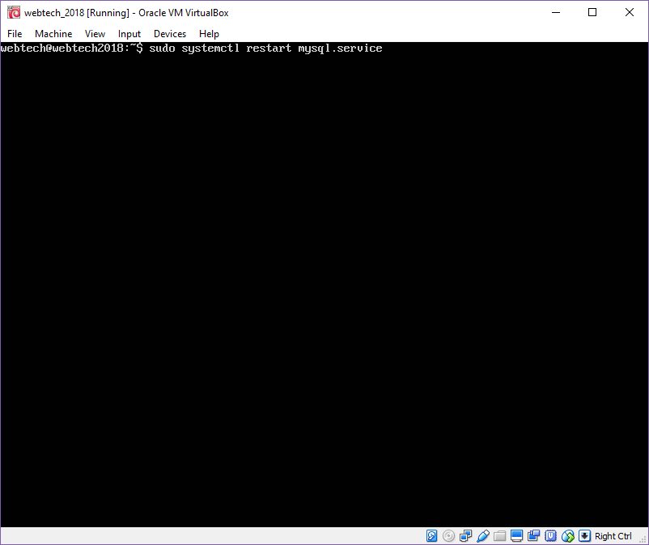

Figure 31: Restarting MySQL.

* + 1. To check the server is running or not, open the webserver and type **http://”IP address of the VM”**.

If the web server is running. Choose what language do you use, then click “Continue”.

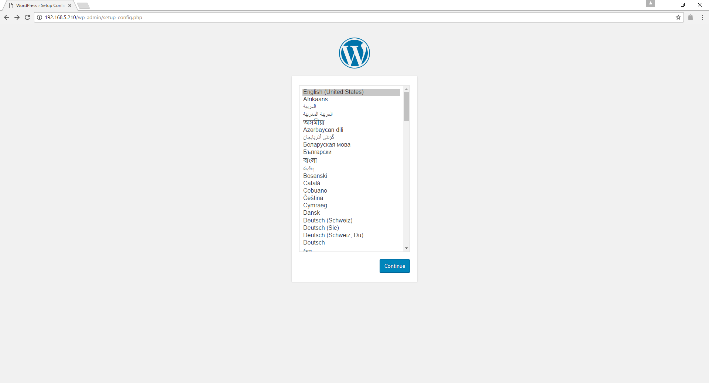

Figure 32: Choosing the language for WordPress.

* + 1. Then it will display the Welcome page of WordPress.

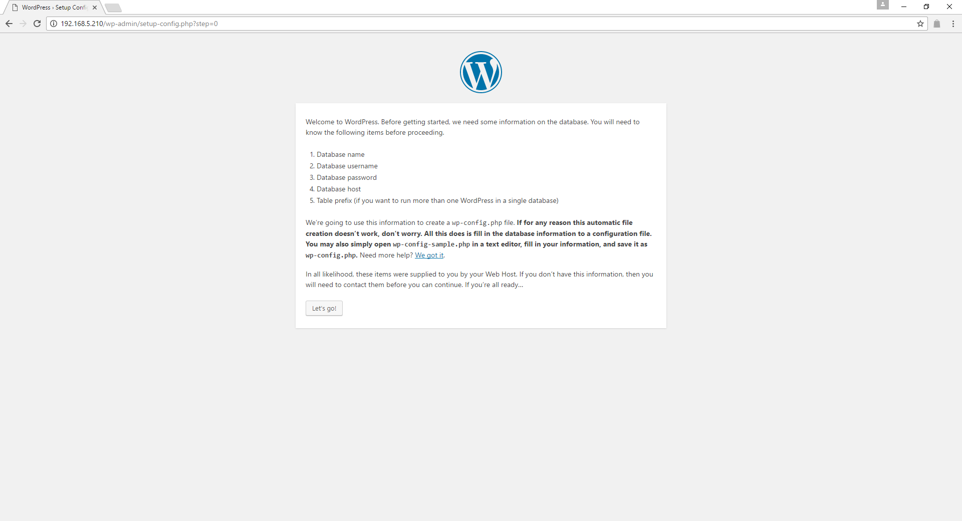

Figure 33: Welcome page of WordPress.

Read the page and click “Let’s go” to proceed to the next page and fill up all necessary information needed and click “Submit”.

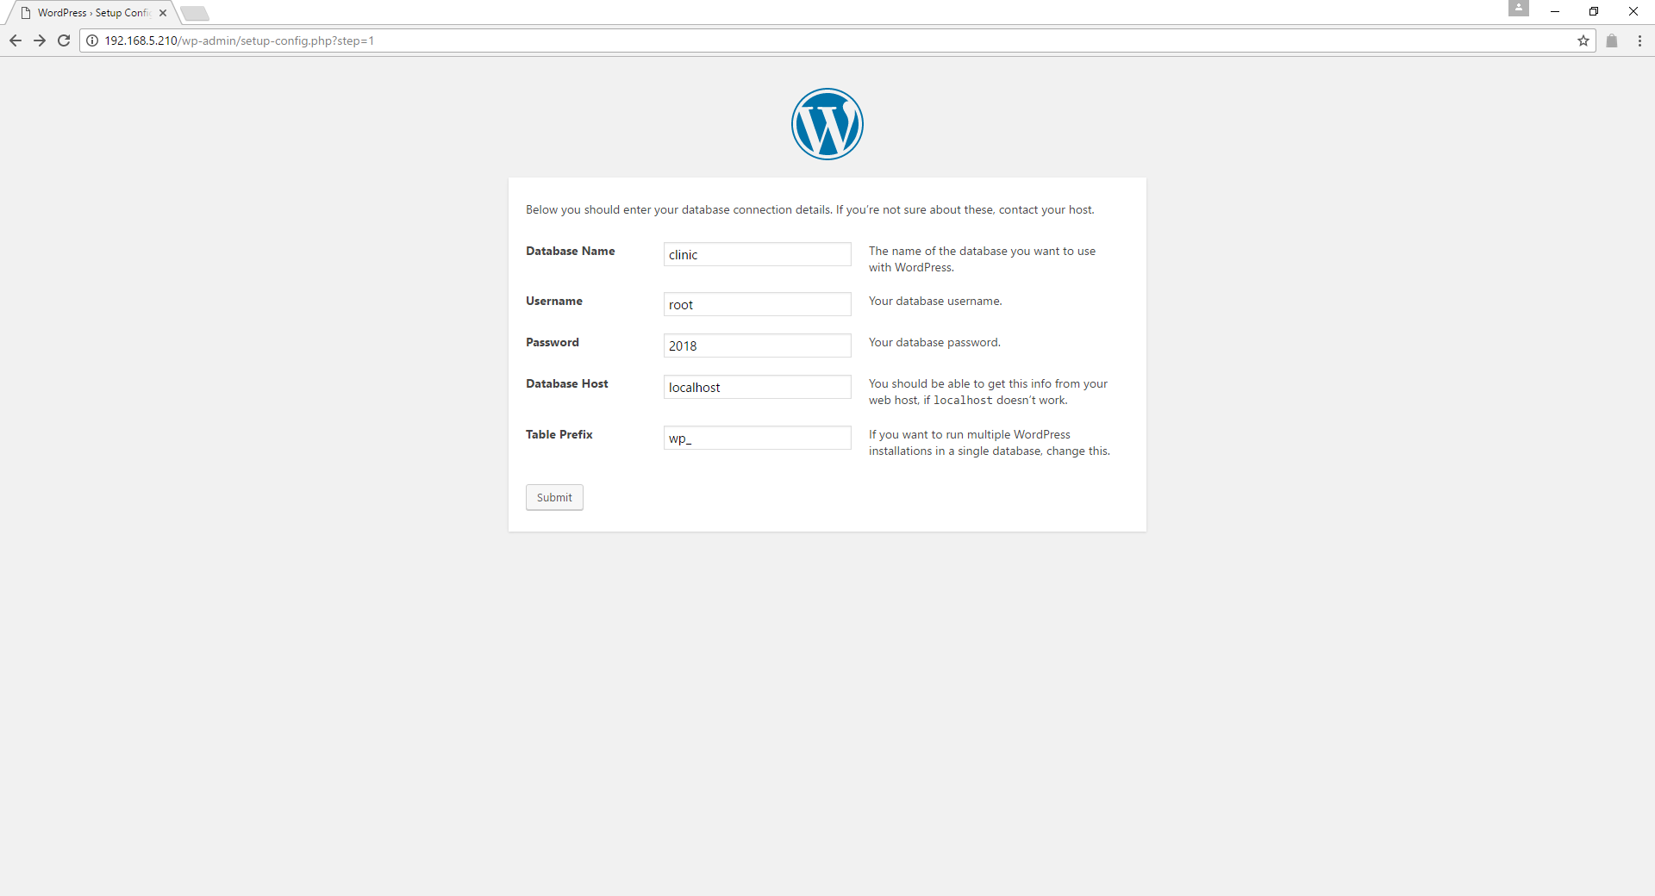

Figure 34: Entering the database details.

It will display a message that WordPress can now communicate with the database. Click “Run the installation” to proceed.

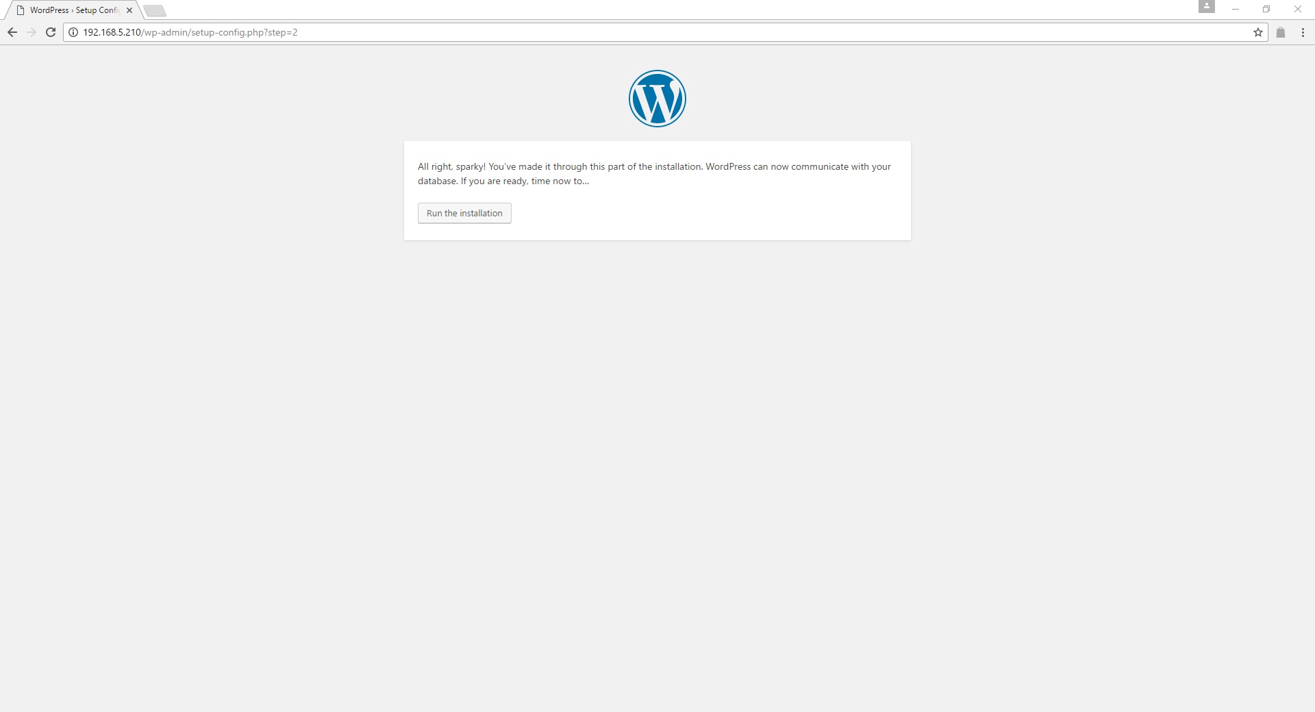

Figure 35: WordPress can now communicate with the database.

Now, fill the necessary information in order to Install Wordpress. Then click “Install WordPress”.

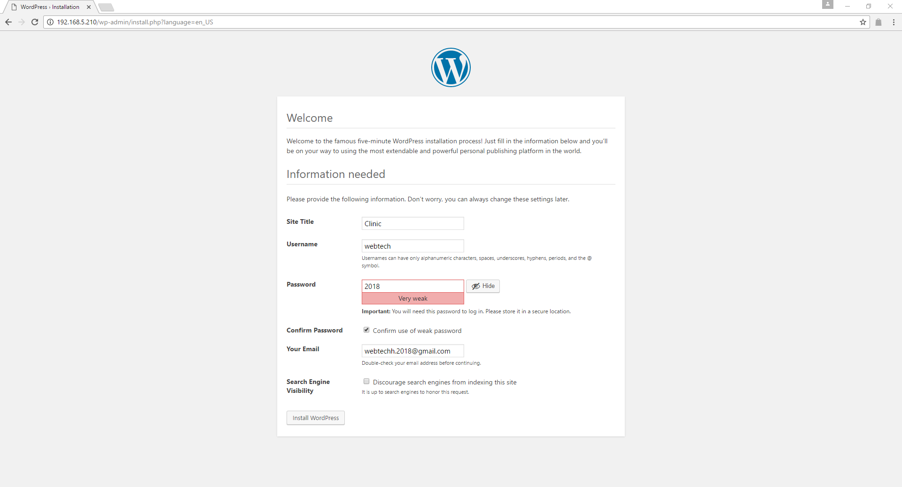

Figure 36: Entering the information needed by the WordPress.

It will display that WordPress is already installed, you can now use WordPress by indicating your Username and Password, then click “Log in”.

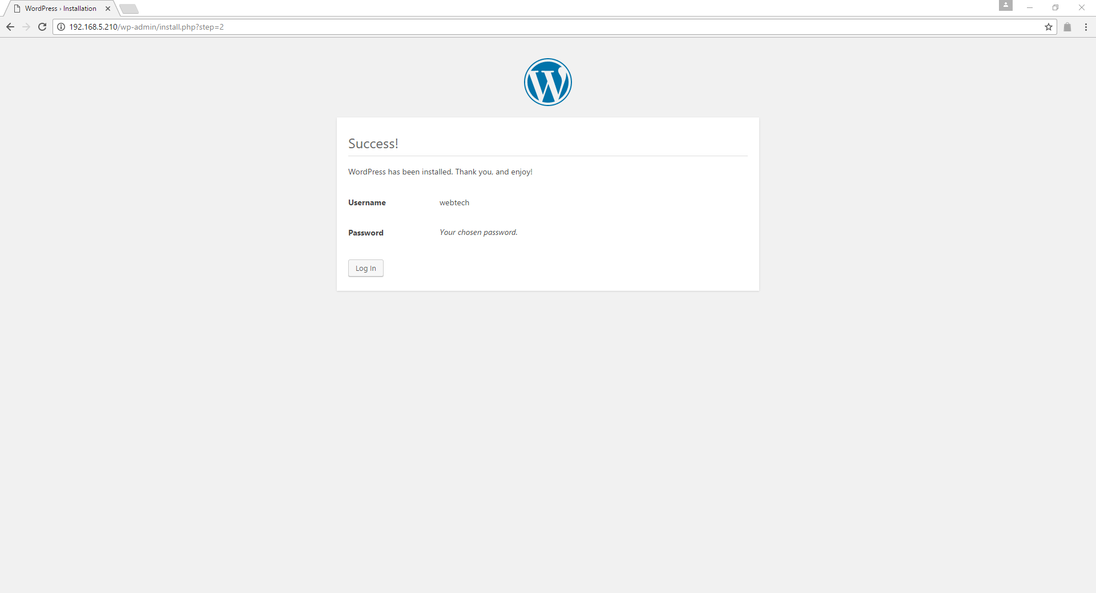

Figure 37: WordPress is successfully installed.